W1D5 Lab

Group members:

*\* 15. Nguyen, Ha Vu Duy  
* 20. Pham, Van ty*

**Question 1:**

1 a/

|  |  |  |
| --- | --- | --- |
| Iteration | Inversions | Number of Inversion |
| 0 | (34,8), (34,32), (34,21), (64,51), (64,32), (64,21), (51,32), (51,21), (32,21) | 9 |
| 1 | (34,32) (34,21), (51,32), (51,21) (32,21) | 5 |
| 2 | (34,32), (34,21), (32,21) | 3 |
| 3 | (32,21) | 1 |

Total number of inversion for Bubble Sort = 18.

1 b/

|  |  |  |
| --- | --- | --- |
| Iteration | Inversions | Number of Inversion |
| 0 | (34,8), (34,32), (34,21), (64,51), (64,32), (64,21), (51,32), (51,21), (32,21) | 9 |
| 1 | (34,32), (34,21), (64,51), (64,32) (64,21), (51,32), (51,31), (32,21) | 8 |
| 2 | (64,51), (64,32) (64,34), (51,32), (51,34) | 5 |
| 3 | (51,34), (61,34) | 2 |
| 4 | (64,51) | 1 |

Total number of inversion for Selection Sort = 25.

1 c/ (illustrate)

**Question 2:**

Sample Instance 4 of Clearable Table.

add, add, add, add, clear, add, clear add, clear, add, add, add, clear, add, add, clear, add, add, clear, add, add, clear.

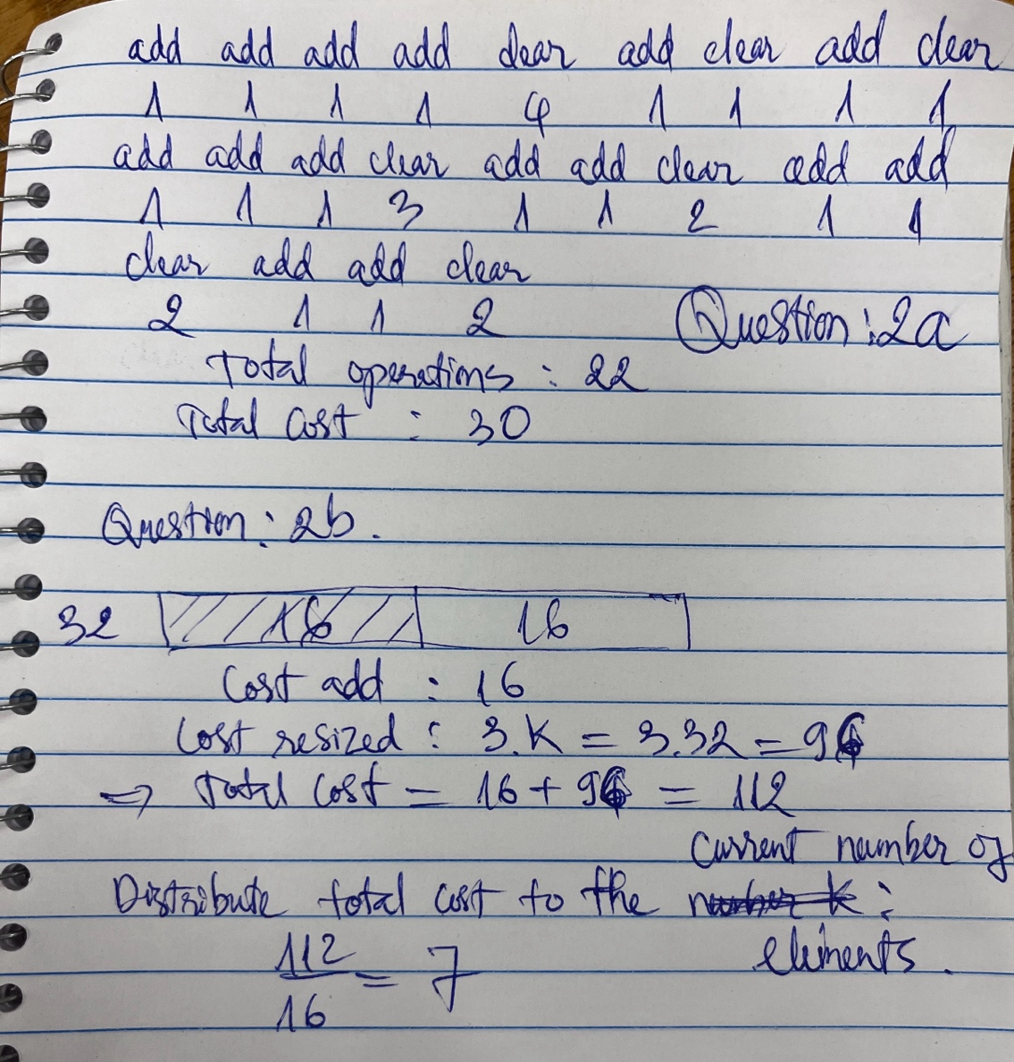

**Question 3:**

